Iron artist
- Source: Global Times
- [01:14 March 30 2010]
- Comments
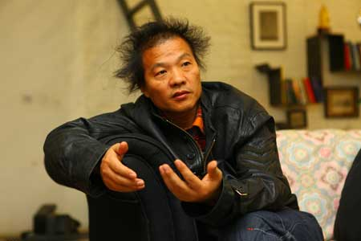
Wang Qingsong
By Vera Penêda
The story of contemporary Chinese art can no longer be told without mentioning Wang Qingsong. His works map 20 years of China's social and economic development. To pour life into his creations is Wang's touchstone to grasp social change.
At 44, he steps into new ground. The premiere of his recent video works at Pékin Fine Arts are a deviation from his gaudy imagery and staged photographs into a fast-paced and visceral realm. In real life Wang's scruffy hair and defiant words match up his work. He says there's no escape: We all must face cast-iron challenges to adjust to change. We just don't have to surrender.
Violent change
His video trilogy is a violent test of the viewer's tolerance, two of them a gory five-minute experience. The first, Iron Man, features Wang himself, quiet, with an opulent black mane, enduring fists ripping his hair and punching his face into a bloody bruised mush.
"This man is hit by all the social forces – physical violence and mental disorder – that attack us in the process of change," the artist explains. "We all must deal with hurdles like stress, competition and personal issues." The battered man finally laughs, insane and defiant. "On the surface he looks defeated, but he sustains until the end," the director says.
The odds overturn in 123 456 Chops. A man under the spotlight chops a sheep corpse into pieces with a butcher knife. In a trance-like state, the man engages in a ritual crushing of the carcass until its remains have sprayed the stage red with the fine powder of blood and guts. "Like in a game, you're caught on by the anger and whirl of rushed development," Wang says.
The butcher walks away in peace, satisfied with the brutal catharsis. Wang criticizes the suc-cess of realistic violence in computer and film entertainment. The viewer is to judge how desen-sitized and resilient he is in the face of random violence.
Skyscraper is poetic but grave. Wang shot a 35-meter tall "skyscraper" of iron scaffolding painted gold rising out of a field of burnt trees. Celebratory white smoke inaugurates the enterprise, progress happens, and fireworks crown the scrawny structure to the calm sound of "Silent Night". "We must dismantle the old to build the new," Wang says.
But big isn't better. "Real estate measures the success of the economic development, looks big and beautiful, but hides other problems. Real estate stresses the contrast of city-country and doesn't solve housing issues," Wang explains, reproving the manic speed of China's flimsy development.
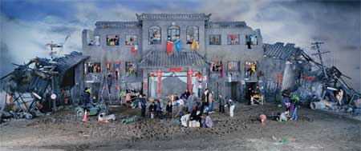
Dream of Migrants. Photos: Wang Zi and courtesy of Pékin Fine Arts
Higher than life
Wang is poignant without words or camera movement. "I don't need dialogue. Some-times the message is more forceful without sound. Every time, speed and repetition tell the story." Mired by the intense atmosphere, viewers become accomplices of a silent observer, the artist-cameraman. "I like to hold the camera from a distance, register the alterations around me, and give space for the audience to imagine and complete the story."
Wang evolved as an artist switching from painting to photography to video. But his artistic prerogative remains unmoved. "I asked myself: 'why should I be an artist locked up in some studio doing paintings? What does that have to do with real life?' I decided to focus my attention in what was around me. I observe social reality and capture its alterations. I just felt I needed a new medium to do that." He feels that something is missing when he looks at stationary images. "I'd like to show the action during the making of the shoot, to translate the process into video."
Wang sees himself as a photojournalist, even though in his photography, he con-sistently enhances and stages reality. "I'm not interested in capturing the instant. The changes I want to portray are a process that occurs over a long period of time. Each corner of my photo might have a moment but the overall is a result of long time observation." He quotes Mao Zedong: "Art comes from life, but art should be higher than life".
Gaudy to gory
Wang's life is inextricable from his artwork; they matured side by side, fed by China's context and his personal buoyancy. His wife Zhang Fang speaks for him in English to tell a story she shares. Wang was working in the oil fields in Hebei Province when he found a drawing that inspired him. "I copied it over and over. I decided I'd be the son who wanted to do better and make a name for my family."
He had to enroll five times to be admitted into the Sichuan Academy of Fine Arts, graduating in 1991. "I came to Beijing in 1993, hopeful, eager to join the frenzy. But I was poor and found a different reality." He tells of frustration in a city where old communal values were gone and everybody wanted to get rich. His earlier oil paintings of distorted faces asphyxiated in plastic bags depict his own confusion and despair.
When painting was no longer effective in capturing the fast pace of China's mutations, Wang turned to photography. His large-scale images emulated real life into a theatrical combustion of color and humor. "Kitschy, but powerful. Contradictory, but critical," Wang described his Gaudy Art in the mid-90s.
The artist reproduced the dreams and frustrations of a globalizing China and its confused appropriation of Western symbols. In Thinker (1998), Wang prays in a medi-tative Buddha pose with the McDonald's logo emblazoned on his chest. "Gaudy art was valid around the early 90s. Everybody was excited about the economic reform. China opened up, many restrictions fell down and people felt relatively free to make money and enjoy a better life. Modernization, commercialization and pop culture made people happy," he recalls, "but things have changed."
Wang disregarded the lighthearted symbols of Western pop culture and the classics. His videos are denser, breaking deeper into an individual field beyond the material and social.
"People are no longer happy as they realize that many achievements in modern China don't benefit the general public. Education and real estate got much more expensive and the general living conditions didn't improve."
Inspired by all the times he managed to get over life's quandaries, Wang's message is clear: "One has no choice but to adapt and handle changes. Like the Iron Man (a Chinese symbol from the 1950s) one must face and overcome life's hurdles smartly, without trepidation, and find a way to move on."
The artistic environment is more relaxed in Beijing now, "as long as you're not reported to the police." But in an art scene where individuality is compromised by official and corporative collaborations, Wang respects artists "who take their art casually" and "truly express their individuality". The artist is working on new sculptures and a three dimensional installation. "My art work is never finished."
The exhibition Wang Qingsong's: Three Video Projects can be seen at Pékin Fine Arts until April 12. www.pekinfinearts.com.
verapeneda@globaltimes.com.cn

